[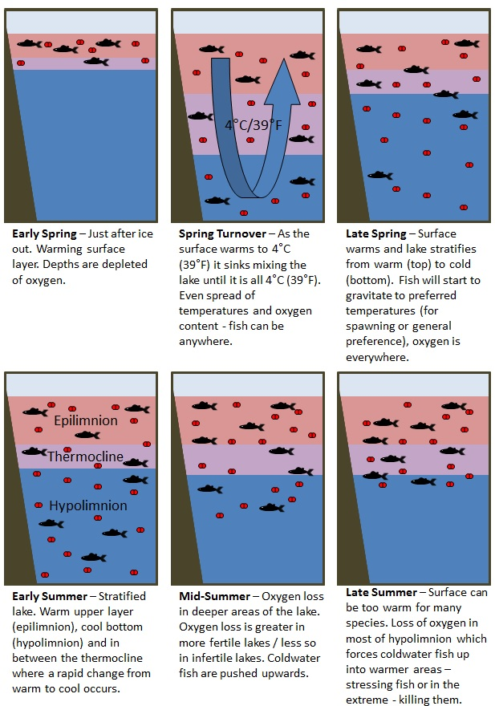](http://thescientificfisherman.com/wp-content/uploads/2014/03/lake-turnover-spring-through-summer.jpg)

[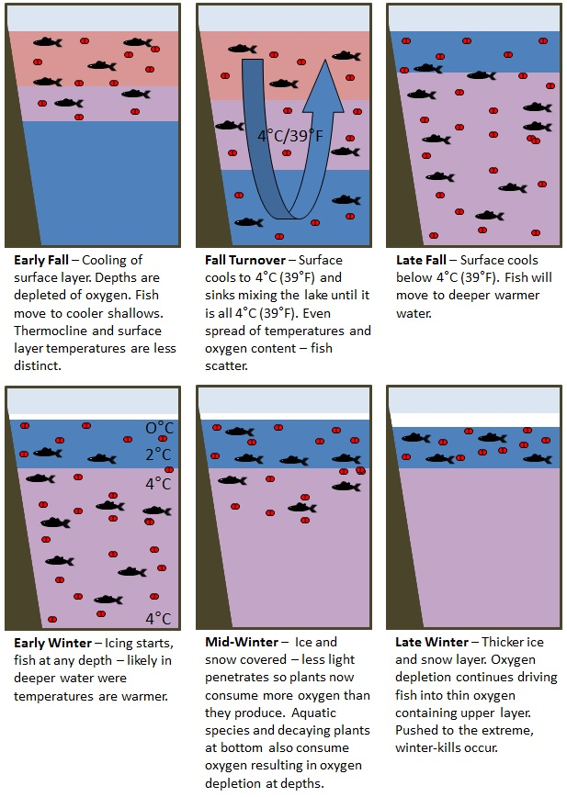](http://thescientificfisherman.com/wp-content/uploads/2014/03/lake-turnover-fall-through-winter.jpg)